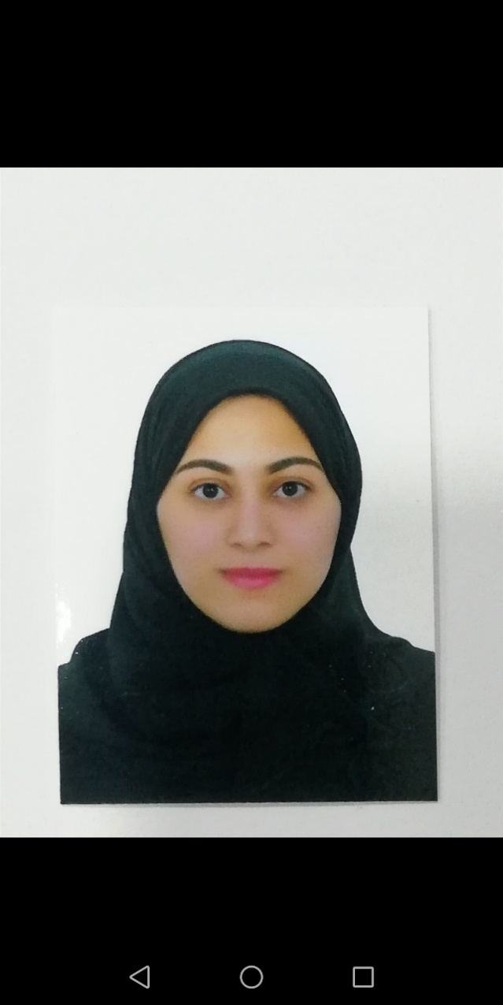yyyfgfgfح

EDUCATION

2012 Esteqlal Secondary School

SKILLS

Computer skills

(Microsoft office - Using internet )

Personal attributes

Teamwork – communication – solving problems - organization

LANGUAGES

English

Arabic

HOBBIES & INTRESTS

Reading

Searching

Using computer

**I am looking for a suitable position in your organization. My overall long term goal is to establish a long term career commitment by competing in challenging mature environments.**

**Scientific**

21-10-1994 ( 25 years )

Tel : (00973) 38260263

E-mail : [Sayeda87@hotmail.com](mailto:Sayeda87@hotmail.com)

Muharraq – Bahrain

PROFESSIONAL CERTIFICATES

International computer driving license (ICDL)

Hawra Sayed Salman Adnan